WiFi Training Program
Module 3 – Assignment
- What are the different 802.11 PHY layer standards? Compare their characteristics.
Standard | Band | Max Speed | Key Feature
802.11b | 2.4 GHz | 11 Mbps | DSSS
802.11a | 5 GHz | 54 Mbps | OFDM
802.11g | 2.4 GHz | 54 Mbps | OFDM
802.11n | 2.4/5 GHz | 600 Mbps | MIMO
802.11ac | 5 GHz | ~6.9 Gbps | MU-MIMO
802.11ax | 2.4/5/6 GHz | ~9.6 Gbps | OFDMA
The IEEE 802.11 PHY layer standards define how wireless signals are transmitted over the air.

- What are DSSS and FHSS? How do they work?
DSSS (Direct Sequence Spread Spectrum) spreads the signal over a wider frequency band using a spreading code, making it resistant to interference and noise. FHSS (Frequency Hopping Spread Spectrum) rapidly switches frequencies within a band using a hopping sequence, reducing interference and improving security. DSSS provides higher data rates compared to FHSS, while FHSS offers better resistance to narrowband interference.
- How do modulation schemes work in the PHY layer? Compare different modulation schemes and their performance across various Wi-Fi standards
Modulation schemes convert digital data into signals for transmission. Common schemes include BPSK, QPSK, QAM (16-QAM, 64-QAM, 256-QAM, 1024-QAM). Lower-order modulations like BPSK are more robust but slower, while higher-order QAM provides higher data rates but requires better signal quality.
Scheme | Bits/Symbol | Performance
BPSK | 1 | Very robust, low speed
QPSK | 2 | Moderate
16-QAM | 4 | Higher speed
64-QAM | 6 | High speed
256-QAM | 8 | Very high speed, less robust

- What is the significance of OFDM in WLAN? How does it improve performance?
OFDM (Orthogonal Frequency Division Multiplexing) divides a wide channel into multiple smaller subcarriers that transmit data in parallel. This reduces interference, improves reliability, and increases data rates. It helps combat multipath fading and is widely used in modern Wi-Fi standards like 802.11a/g/n/ac/ax.
- How are frequency bands divided for Wi-Fi? Explain different bands and their channels.
Wi-Fi operates mainly in 2.4 GHz, 5 GHz, and 6 GHz bands. The 2.4 GHz band has fewer channels (overlapping), leading to congestion. The 5 GHz band offers more non-overlapping channels and higher speeds. The 6 GHz band (Wi-Fi 6E) provides even more spectrum and less interference. Channels are divided based on frequency ranges and bandwidth (20 MHz, 40 MHz, 80 MHz, 160 MHz).
- What is the role of Guard Intervals in WLAN transmission? How does a short Guard Interval improve efficiency?
A Guard Interval (GI) is a small time gap between transmitted symbols to prevent inter-symbol interference caused by multipath signals. A shorter GI (e.g., 400 ns instead of 800 ns) increases data transmission efficiency and increases throughput.
- Describe the structure of an 802.11 PHY layer frame. What are its key components?
An 802.11 PHY frame consists of a preamble, header, and payload. The preamble is used for synchronization, the header contains information like data rate and length, and the payload carries the actual data. These components ensure proper transmission and decoding of signals.
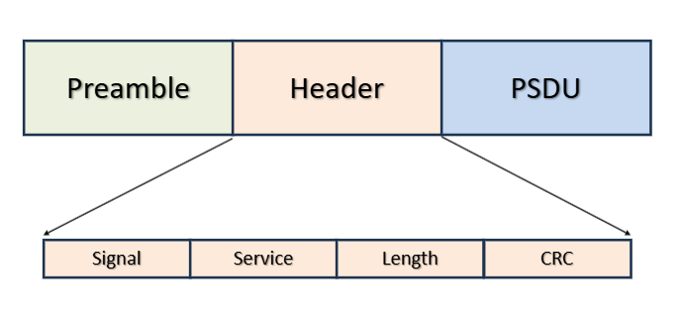
- What is the difference between OFDM and OFDMA?
OFDM (Orthogonal Frequency Division Multiplexing) allows a single user to transmit data over multiple subcarriers simultaneously. OFDMA (Orthogonal Frequency Division Multiple Access) extends this by allowing multiple users to share subcarriers at the same time, improving efficiency and reducing latency in high-density networks (used in 802.11ax).
Feature | OFDM | OFDMA
User Support | Single User | Multiple Users (Multi-user)
Subcarrier Usage | All assigned to 1 user | Divided among multiple users
Throughput | Lower | Higher
Latency | Higher | Lower (Low latency)
Best For | High-bandwidth single connections | Dense, multi-user, IoT applications
Standard Usage | Wi-Fi 5, 4G LTE | Wi-Fi 6, 5G NR

- What is the difference between MIMO and MU-MIMO?
MIMO (Multiple Input Multiple Output) uses multiple antennas to transmit data to a single user, increasing speed and reliability. MU-MIMO (Multi-User MIMO) allows simultaneous data transmission to multiple users, improving network efficiency and reducing congestion.
- What are PPDU, PLCP, and PMD in the PHY layer?
PPDU (PLCP Protocol Data Unit) is the complete PHY frame created by the PLCP, consisting of a preamble, header, and the data (PSDU) transmitted over the air. PLCP (Physical Layer Convergence Protocol) prepares data for transmission by adding headers and formatting. PMD (Physical Medium Dependent) handles actual signal transmission like modulation and transmission over the medium.
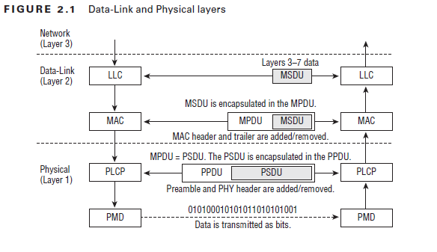
- What are the types of PPDU? Explain the PPDU frame format across different Wi-Fi generations.
PPDU (PLCP Protocol Data Unit) is the 802.11 physical layer frame, comprising a preamble, header, and data (PSDU). Types include Legacy (Non-HT), High Throughput (HT), Very High Throughput (VHT), High Efficiency (HE), and Ultra High Efficiency (UHR), evolving from single-user to complex Multi-User (MU) formats with increased efficiency.
- How is the data rate calculated?
The data rate in Wi-Fi depends on bandwidth, modulation scheme, coding rate, number of spatial streams, and guard interval. It is calculated as:
Data Rate = (Number of subcarriers × bits per symbol × coding rate × spatial streams) / symbol duration. Higher bandwidth, higher modulation (like 1024-QAM), and more spatial streams result in higher data rates.
